CS106 - Assessment 2

Contents

❖ Project Description 2

Team members and responsibilities 2

Goals and Objectives 2

❖ System Modelling 2

❖ Project Implementation Screenshots 5

❖ Project Functionality Testing 5

Software Process model/s 5

Tools 6

❖ Installation Guide 7

❖ My Learning Experience Summary 8

❖ Presentation 8

❖ References 9

❖ Project Description

To create a Covid Tracing app, with appropriate accessibility / management available at user level, and administrator level. All information is to be behind a log in – either admin or user. A QR code should show a user their own test / vaccination record. (Used for verification purposes by other businesses). Lastly, users should be able to download vaccination and COVID-19 test certificates.

## Team members and responsibilities

Responsibilities are shared, team members can work on one or several categories, but categories should be managed by specified team member, predominantly.

Finlay Macbeth: 1. Project Description: (all subcategories)

Auren Smith: 2. Software Requirements analysis and specification (Planning) (all subcategories)

Elena Siljic: 3. UI Design (Figma Designs & Style guide)

***NZ COVID Vaccine Information System***

## Goals and Objectives

To create a Covid Tracing app, with appropriate accessibility / management available at user level, and administrator level. All information is to be behind a log in – either admin or user. A QR code should show a user their own test / vaccination record. (Used for verification purposes by other businesses). Lastly, users should be able to download vaccination and COVID-19 test certificates.

❖ System Modelling

- System architecture

1. Users should be able to create a new account or log into the system.
2. The Administrator should be able to log in to the system.
3. The Administrator should be able to view and modify users' information.
4. The Administrator should be able to upload and maintain users' documents.
5. After logging in, users should be able to view their details in the system.
6. After logging in, users should be able to view their COVID-19 tests and vaccine records.
7. All users should get a unique QR code and logged in users should be able to view their unique QR code for entry requirements.
8. Users should be able to report issues they would encounter in the system.
9. The system should log messages in three different files for the following:
10. When certificates are uploaded.
11. When the test results are uploaded.
12. When users report issues.
13. A “Vaccination Status” should be changed according to the number of doses the user has

received:

1. Unvaccinated
2. Partial
3. Completed

People support the simple and clean design that was originally planned, so we can keep this simplicity. The colour scheme was also appreciated however, some feel it hasn’t been used to its full potential. This can be improved upon by utilizing the current button design more frequently, instead of using text links. More information can also be shown as some think removing information for simplicity makes it feel more complex.

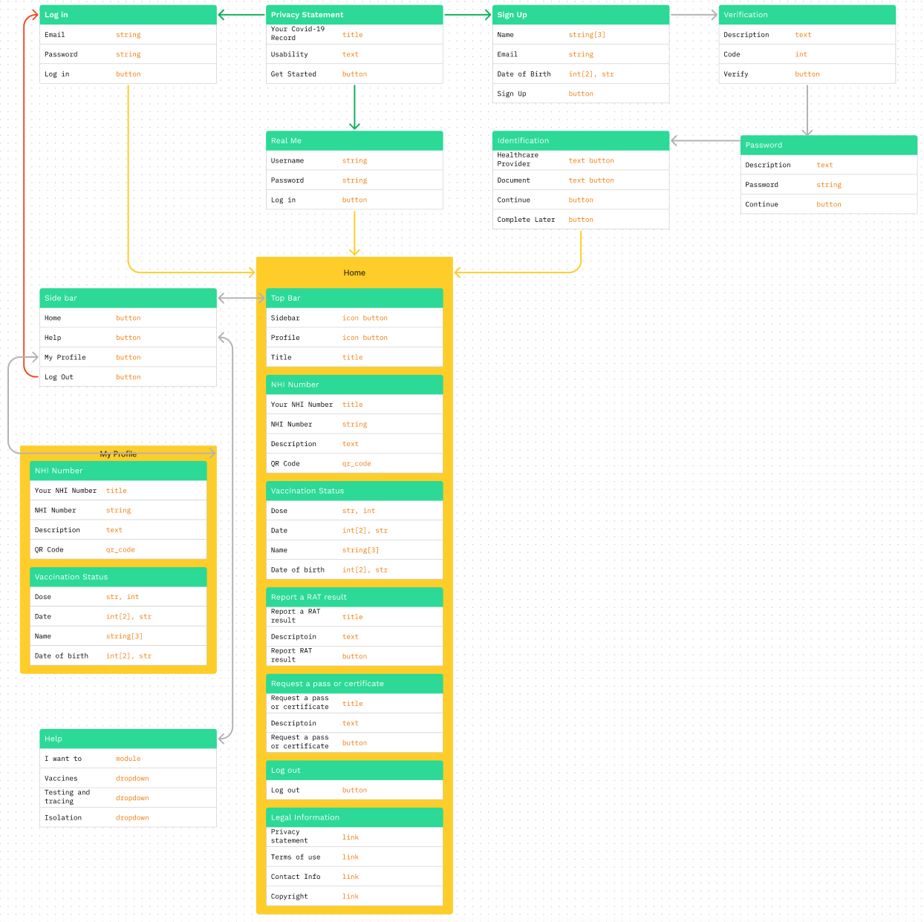

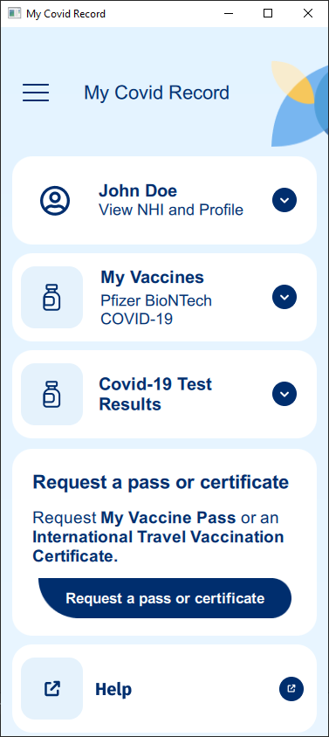❖ Project Implementation Screenshots

Software Process model/s

***Source of Information on Software Process Models:*** (Indeed Editorial Team, n.d.)

* Waterfall model:

*“The waterfall software process model is one of the simplest and most effective software process models. The waterfall model displays each step of the development process as a separate, sequential step so that it's easy to follow.”*

* Iterative Waterfall model

*“Iterative development typically consists of four phases:*

* + - *Inception: The team establishes a business case for the system.*
    - *Elaboration: The team identifies risk, develops a project plan, and creates system architecture.*
    - *Construction: The team develops parallel components.*
    - *Transition: The team delivers the system into its operating environment for customer review.”*
* Rapid Application Development (RAD):

*“The RAD model, or*[*rapid application development*](https://www.indeed.com/career-advice/career-development/rapid-application-development)*model, combines rapid prototyping with incremental development. This helps provide better feedback for the developers with prototypes for the customer and development at an incremental rate.”*

* Spiral:

*“The spiral model is like the waterfall model but includes risk assessment. These assessments help the team identify potential risks during the project's development, allowing for faster response times and more realistic expectations for the customer during development.”*

From this list of four researched software process models, we have concluded that the waterfall method is the most simplistic, which will help both of us as the dev team, and the client follow along, and understand the steps one at a time. We have chosen the ‘simple is best’ approach.

### Tools

* C++
* QML
* Javascript
* QT Application Development
* GitHub
* Figma

❖ Installation Guide

To run the application executable, go to: “My Covid Record Executable\MyCovidRecord.exe” from the folder given for the assessment submission.

1. Put the unzipped folder “My-Covid-Record” into any path

(I will be using “C:\My Covid Record\My-Covid-Record” as the example directory”

1. Open “QT Creator”
2. In the “Welcome” tab, press “Open Project”
3. Go to “C:\My Covid Record\My-Covid-Record\MyCovidRecord\CMakeLists.txt” and click “Open”
4. Then go to the “Projects” tab, press on the “Build” button
5. Press “Browse…” and change the “Build directory:” to “C:\My Covid Record\My-Covid-Record\build-MyCovidRecord-Desktop_Qt_6_4_0_MinGW_64_bit-Debug” and press “Select Folder”
6. Then go back into File Explorer and navigate to “C:\My Covid Record\My-Covid-Record\build-MyCovidRecord-Desktop_Qt_6_4_0_MinGW_64_bit-Debug”
7. Find “CMakeCache.txt” and “CMakeCache.txt.prev” and delete them both.
8. Go back to QT Creator and go to the “Edit” tab
9. Right click on the root folder “MyCovidRecord” (in my case “MyCovidRecord [main]”)
10. Click on “Run CMake”
11. To test if everything works. In QT Creator in the “Edit” tab and navigate to:

qml.qrc --> / --> application.js

1. Edit “var title = “My Covid Record” to “var title = “Test”
2. Save, then run the application
3. If the window is titled “Test” everything has been setup correctly, however if the windows title is “My Covid Record” make sure you have done steps 5 – 15 properly.
4. Once everything is setup correctly change the “var title = “Test” back to “var title = “My Covid Record”

## ❖ References

Indeed Editorial Team. (n.d.). *Indeed - What is Software Process Model*. Retrieved from Indeed: https://www.indeed.com/career-advice/career-development/what-is-software-process-model